AFEEFA KHALID-BSE233218

AYESHA JAMEEL-BSE233097

AHMED MALIK-bse233223

GITHUB LINK:

1. **Description of Entities, Attributes, and Relationship**

**Entities and Attributes:**

1. **Donor:**

* **Primary key:** Donor-id
* **Attributes:** name, age, blood type, contact-number, address, last-donation-date.

1. **Donation:**

* **Primary key:** Donation-id
* **Attributes:** Donor-id, date-of-donation, blood-quantity, blood-type, donation-center.

1. **Blood-inventory:**

* **Primary key:** Inventory-id
* **Attributes:** blood-type, quantity-available, expiry-date, storage-location, donation-id.

1. **Recipient:**

* **Primary key:** Recipient-id
* **Attributes:** name, age, blood-type-needed, hospital-id, contact-number, request-date.

1. **Hospital:**

* **Primary key:** Hospital-id
* **Attributes:** hospital-name, location, contact-number, blood-bank-affiliation, emergency-level.

1. **Blood-request:**

* **Primary key:** Request-id
* **Attributes:** Recipient-id, blood-type-requested, quantity-requested, fulfilment-status, request-date.

**Relationships:**

1. **Donor-Donation:**

**Relationship:** A donor can make multiple donations, but each donation is linked to one donor.

**Degree:** Binary

**Cardinality:** one-to-many

1. **Donation-Blood inventory:**

**Relationship:** Each donation updates the blood inventory; one inventory record contain record of one or more donations.

**Degree:** Binary

**Cardinality:** one-to-many

1. **Recipient-Blood request:**

**Relationship:** A recipient can make multiple blood request and each request has separate recipient

**Degree:** Binary

**Cardinality:** one-to-many

1. **Blood inventory –Hospital:**

**Relationship:** A hospital has access to more than one blood inventory and each inventory record can be accessed by more than one hospital if needed.

**Degree:** Binary

**Cardinality:** many-to-many

1. **Hospital-Recipient:**

**Relationship:** A hospital can serve multiple recipients and each recipient is associated with one hospital.

**Degree:** Binary

**Cardinality:** one-to-many

1. **Blood request -Blood inventory:**

**Relationship:** Each blood request form access more than one inventory record and each inventory satisfy multiple blood request.

**Degree:** Binary

**Cardinality:** many-to-many

1. **Challenges and Considerations**

* **Normalization**:

No data redundancy while being high on performance and scalable

* **Data Integrity**:

Keeping tables in sync when updating donations and inventories.

* **Scalability**:

Creating a flexible design that allows for the addition of other attributes (e.g., donor medical history)

* **Real-World Complexity**:

This is considering edge cases where a donations is divided for multiple uses or hospitals share the same inventory.

* **Constraints**:

Implementing business rules such as matching blood-types for requests & donation

1. **Tables, Fields, and Data Types**

|  |  |  |
| --- | --- | --- |
| Table Name | Fields | Data Types |
| **Donor** | Donor ID (PK) | INT |
|  | Name | VARCHAR(100) |
|  | Contact number | VARCHAR(150) |
|  | Blood Type | CHAR(3) |
|  | Age | INT |
|  | Address | INT |
|  | Last-donation date | DATE |

|  |  |  |
| --- | --- | --- |
| Table Name | Fields | Data Types |
| **Donation** | Donation ID (PK) | INT |
|  | Donor ID (FK) | INT |
|  | Date of donation | DATE |
|  | Blood Type | CHAR(3) |
|  | Blood Quantity | DECIMAL(5,2) |
|  | Donation center | INT |

|  |  |  |
| --- | --- | --- |
| Table Name | Fields | Data Types |
| **Blood Inventory** | Inventory ID (PK) | INT |
|  | Quantity available | INT |
|  | Blood Type | CHAR(3) |
|  | Expiry date | DATE |
|  | Storage location | INT |
|  | Donation id | INT |

|  |  |  |
| --- | --- | --- |
| Table Name | Fields | Data Types |
| **Recipient** | Recipient ID (PK) | INT |
|  | Name | VARCHAR(100) |
|  | Contact number | VARCHAR(150) |
|  | Blood Type needed | CHAR(3) |
|  | Age | INT |
|  | Hospital id | INT |
|  | Request date | DATE |

|  |  |  |
| --- | --- | --- |
| Table Name | Fields | Data Types |
| **Hospital** | Hospital ID (PK) | INT |
|  | Hospital Name | VARCHAR(100) |
|  | Location | VARCHAR(150) |
|  | Contact number | INT |
|  | Blood bank affliation | INT |
|  | Emergency level | INT |

|  |  |  |
| --- | --- | --- |
| Table Name | Fields | Data Types |
| **Blood Request** | Request ID (PK) | INT |
|  | Fulfilment status | INT |
|  | Recipient ID (FK) | INT |
|  | Blood Type | CHAR(3) |
|  | Quantity | DECIMAL(5,2) |
|  | Date | DATE |

1. **Establishing Relationships**

* **Donor-donation** (Donor-id PK in donor and FK in donation)
* **Donation-Blood inventory** (Donation-id PK in donation and FK in blood inventory)
* **Recipient id-blood request** (Recipient-id PK in recipient and FK in blood-request)
* **Hospital id –recipient** (Hospital-id PK in hospital and FK in recipient)

1. **Transformation of ERD into Relational Data Model (RDM)**

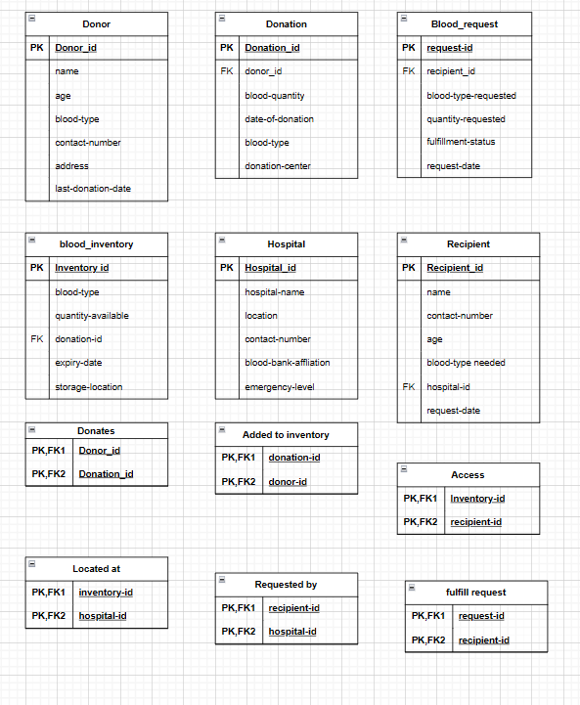

1. **Report on Design Decisions**

* **Entity Identification**: We identified key entities based on the core functionalities of a blood donation management system. The focus was on donors, donations, blood inventories, hospitals, recipients, and requests.
* **Normalization:** Tables were designed to eliminate redundancy. For example, blood type data is not duplicated unnecessarily across multiple entities.
* **Relationships and Integrity:** Foreign keys were implemented to maintain relationships between entities, ensuring data consistency. For example, DonorID in the Donation table links to the Donor table.
* **Challenges Addressed:**
* Ensured flexibility in blood inventory management by linking donations indirectly through a process.
* Addressed potential future scalability by allowing for additional attributes or entities without redesigning the schema.
* **Data Types:** Data types were chosen to optimize storage and enforce constraints. For instance, CHAR(3) was used for BloodType to represent standardized blood groups (e.g., "A+", "O-").